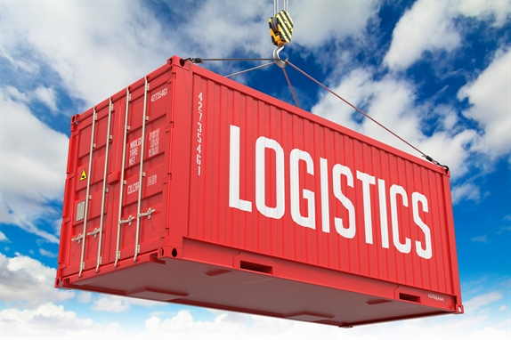



Creative of warehouse procedure in all activities and facilities

**Introduction:**

For any large manufacturer, producer or distributor, the efficient operation and management of the warehouse is a key area where competitive advantage can be gained and exploited.

From the fundamentals of warehouse management and warehouse management systems, to performance and information management, this training course has been designed to meet the professional development needs of all those involved in the management of large warehouse and distribution facilities.

**Key Learning Outcomes:**

* The fundamentals of warehouse management
* Warehouse design, layout & equipment
* Measuring & managing warehouse performance
* Opportunities for warehouse improvement
* Your responsibilities in health & safety
* Managing & motivating warehouse staff

**Course Outline:**

**The fundamentals of effective warehouse management**

* How does your warehouse fit into the organization’s corporate strategy?
* How your warehouse fits into the overall supply chain of the company?
* What are the key functions & operations of a typical warehouse?
* Warehousing equipment: Ensuring the right tool for the right job

**Storage equipment**

* Conveyor equipment
* Forklift equipment
* Manual equipment

**Effectively managing your OHS obligations in the warehouse**

* What are the health and safety responsibilities for the employer?
* How can an effective health and safety program benefit your organization?
* What can you do to ensure organizational buy in?

**Designing effective warehouse layout**

* What issues do you need to consider for optimal layout?
* What are potential problem areas?
* Making the trade-off – space and time issues
* Practical exercise: Designing an effective warehouse layout

**Tools to optimize warehouse performance**

* Visual Performance methods
* Lean tools

**Managing the flow of information and identifying key performance indicators in your warehouse**

* Practical exercise: Managing the performance of your warehouse
* What information is important to your warehouse and why?
* Developing KPIs
* What are the key issues and challenges of measuring performance?
* What are the roots of poor performance and how can you improve upon them?
* Productivity evaluation techniques

**Inventory management**

* What is inventory management?
* Managing and controlling inventory
* Identifying areas where inventory can get out of control
* Cycle counting process

**Managing and motivating your warehouse and staff**

* Understanding motivation and its impact on your staff
* Measuring your staff satisfaction
* How can you increase the involvement of staff?